Force, Motion and Energy

Distance and Displacement
- Distance and displacement both describe the amount a body has moved from one location to another.
- Distance is the length of the path the body follows. It is measured in metres (m)
- Displacement takes into account the direction travelled. It is the distance between the initial and final positions as measured in a straight line. It is also measured in metres.
- In an athletic event such as the 400m, the distance travelled is not the same as the displacement due to it starting and finishing at the same place!

Activity
Handout: Distance & Displacement
OHP: Class exercise: Mr Martins Trip

Speed & Velocity
- The rate at which a body moves from one location to another is usually described as either speed (s) or velocity (v)

Average velocity (ms⁻¹) = Distance covered (m)
Time taken (s)

d
v t

- With reference to the last exercise; if it took 96 hours to travel from Seattle to New York (non-stop) calculate average speed as kmh⁻¹ ( 48kmh⁻¹)
- Egs:
- What is the speed of a car in kmh⁻¹ if it covers 15km in 30 minutes?
- Find the speed of a runner in ms⁻¹ if she covers 1000m in 7 minutes.

Converting Units
kmh⁻¹ is converted to ms⁻¹ by…… x 1000 (m in km)
÷ 3600 (s in hr)

ms⁻¹ is converted to kmh⁻¹ by ….. x 3600
÷1000

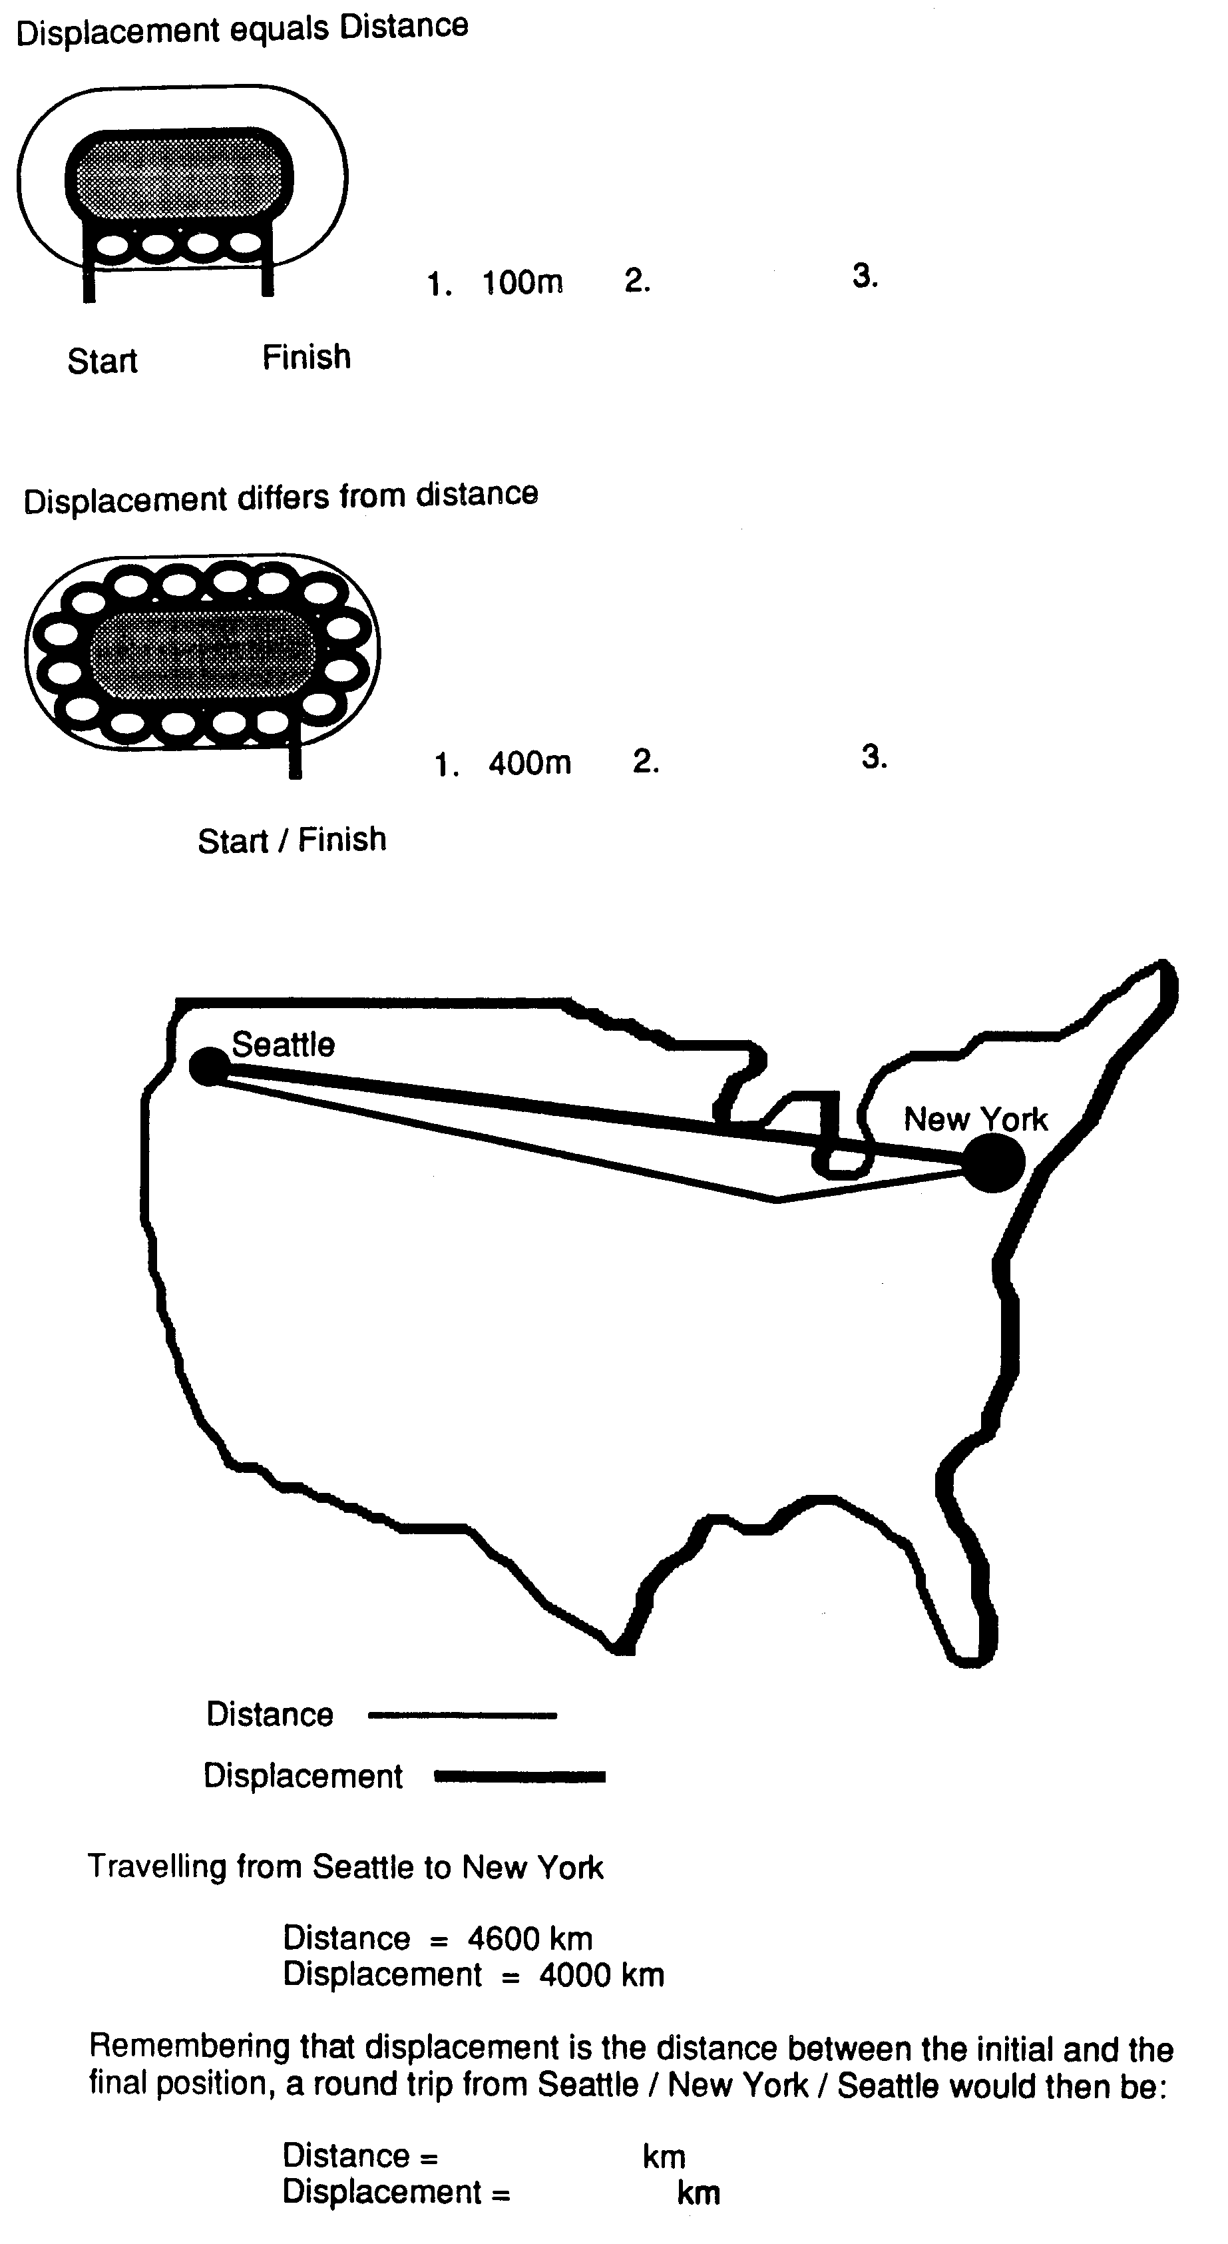

- Egs:
- A cricket ball is bowled at 134km per hour.
- Convert 134 kmh⁻¹ to ms⁻¹ (37.22)
- If the batsman is 18 m from the bowler when the ball is released, how long has he to prepare this stroke? (about 0.5 s)
- Stephen fancied himself as a tennis player. He asked Peter to time his serves from the serve line to the netting fence (30m)
- Find the speed of the serve in metres per second if the measured time was 1.2s. (25)
- Convert this speed to kmh⁻¹

Activity:
Motoring Madness p67 Yellow Practical manual

Measuring Speed in the Laboratory p70-72 ( Get results as a demo) – Before doing speed-time graph, teach acceleration (below)

*Give them some fake ticker timer results and ask the trend ie constant, acc, dec

Hwk: A Toy car Journey p73-4 Yellow Practical manual

Distance-Time Graphs

d stop

constant speed

Acceleration
- An object changing its speed is accelerating – positively or negatively (decelerating)

Acceleration (ms⁻²) = final velocity – initial velocity (Δv)
Time taken (s)

v
a t

- Eg: Calculate acceleration of a trolley which changes from 2ms⁻¹ to 5ms⁻¹ in 2 seconds.
a = 5-2 ÷ 2 = 1.5ms⁻²

Activity:
Finish speed-time work in practical book p72

Velocity-Time graphs

v constant speed

acc^{n}

t

Activity:
Pathfinder: p38-9 no’s 3, 4, 5, 6, 7, 10,11

Acceleration Activity

Homework: Handout: Quick Reflexes

Handout: Worksheet on “Falling”
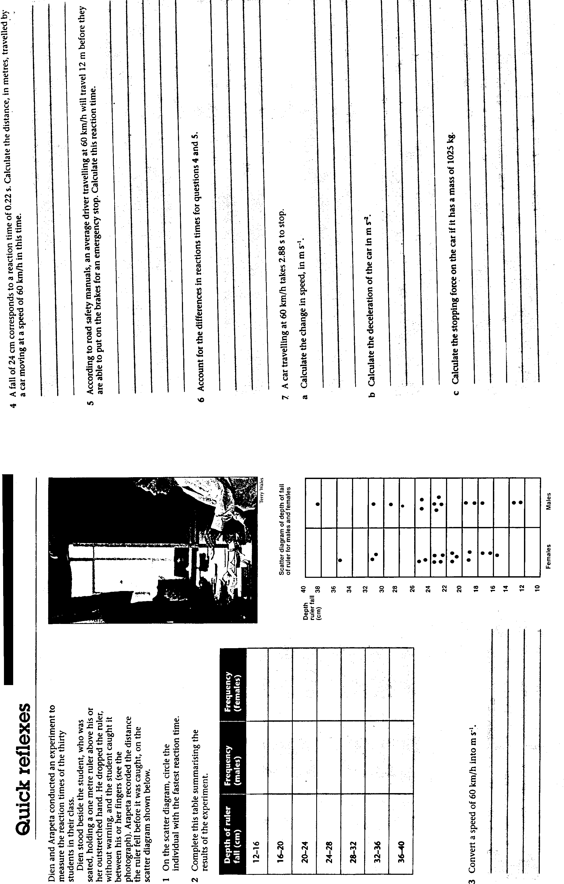

Acceleration

Method:
- Form groups of 6
- Choose one member of your group to run 50 metres at maximum speed
- The remainder of the group collect a stopwatch each and place themselves at every 10 metres.
- On the “go” signal, the runner starts sprinting around the course at maximum speed and all the timers start their stopwatches. As the runner passes each recording position, the timer at that mark stops his/her watch and records the time the runner passed their station
- Fill in the results section and work through the questions

Displacement | Time(s) | Velocity for 10m interval (ms⁻¹) | Final-Initial velocity | Acceleration  (ms⁻²)
10m
20m
30m
40m
50m

Construct a velocity-time graph and using the graph, describe the acceleration. Can you calculate the acceleration from the graph?

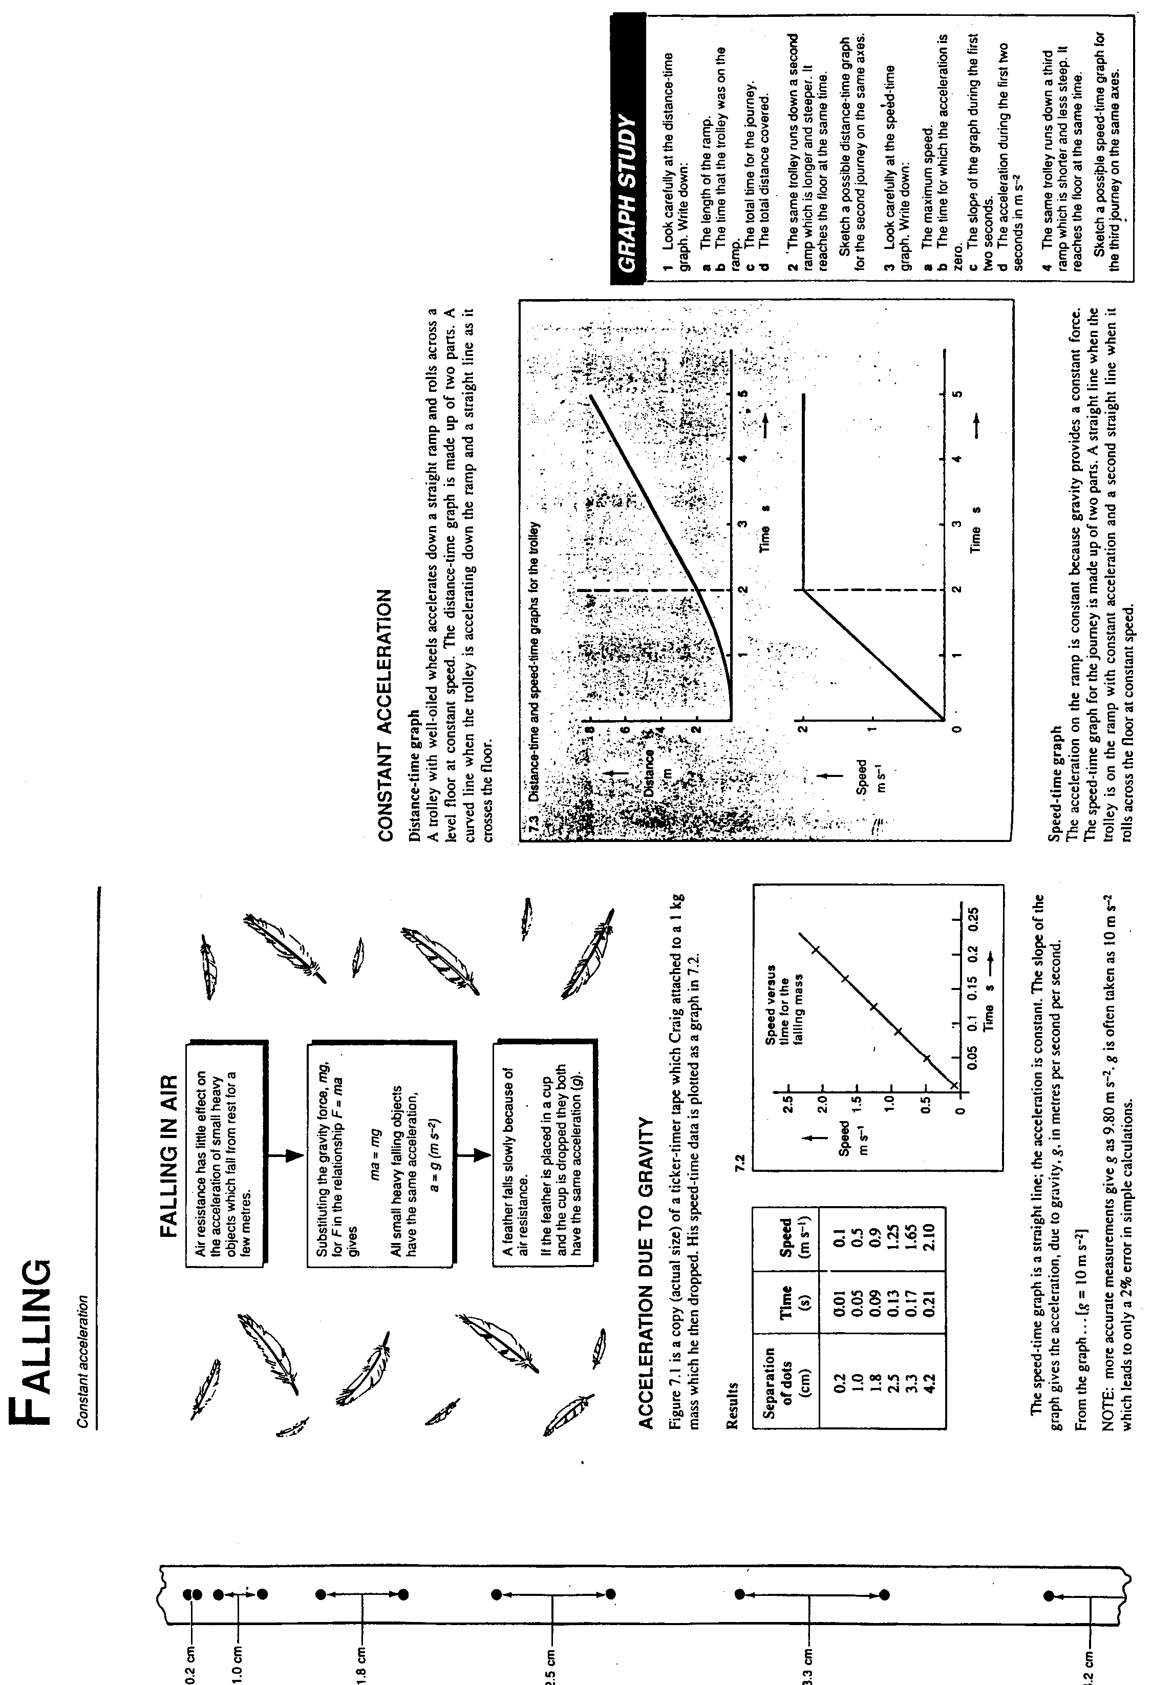

Mass and Weight

- Astronauts are weightless in space but they’re not thinner! The amount of matter in their body hasn’t changed. This is their mass (kg)
- Weight is a measure of the force of gravity on a mass and is measured in Newtons (N)

Weight = mass *g
F_{w} = m.g

- Gravity forces objects to accelerate towards centre of earth at 10ms⁻² or 10Nkg⁻¹
- Weight changes as you move away from the earth’s surface
- The force of gravity on the moon is 1/6 of that on the moon

Questions:
- Jill has a mass of 54 kg. What is her weight in Newtons on Earth? What about on the moon?
- What is the approximate force due to gravity of the following masses:
6kg 600g 4g 72kg
on earth? On the moon?

Activity:
Yellow Practical Book: p79 A Weighty Problem

Forces
- A push, pull or twist which can change an objects motion
- The unit of force is the Newton (N)

Activity:
Blue book p49 : Answer the following questions as notes.
- What are action and reaction forces?
- What are balanced and unbalanced forces?
- How do you calculate the unbalanced force?

Momentum

Activity:
Planning Exercise: Collisions p75 Yellow Prac book –HOMEWORK
Carry out plan then answer questions p78
Demo:
Spin a fresh egg and stop it spinning and repeat with a boiled egg, is there a difference?

Force, Mass and Acceleration
- Newton’s Second Law of Motion
- When a body is acted on by force…
- The greater the force the greater the acceleration
- The smaller the mass, the greater the acceleration
- The change in motion takes place in the direction in which the force is applied

Force(N) = mass (kg)* acceleration(ms⁻²)
F= m.a NB: Unit can also
be kgms⁻²

Activity:
Aliens OHP worksheet
Step on it! Worksheet
May the Force be with you p81-2 Yellow Practical book

Compare slopes of velocity time graphs if force is changed ie increased force is increased gradient

Compare slope of velocity time graphs if mass is changed ie increased mass is decreased gradient.

Activity:

Pathfinder p42-3 no’s 4,6,7,8,10,
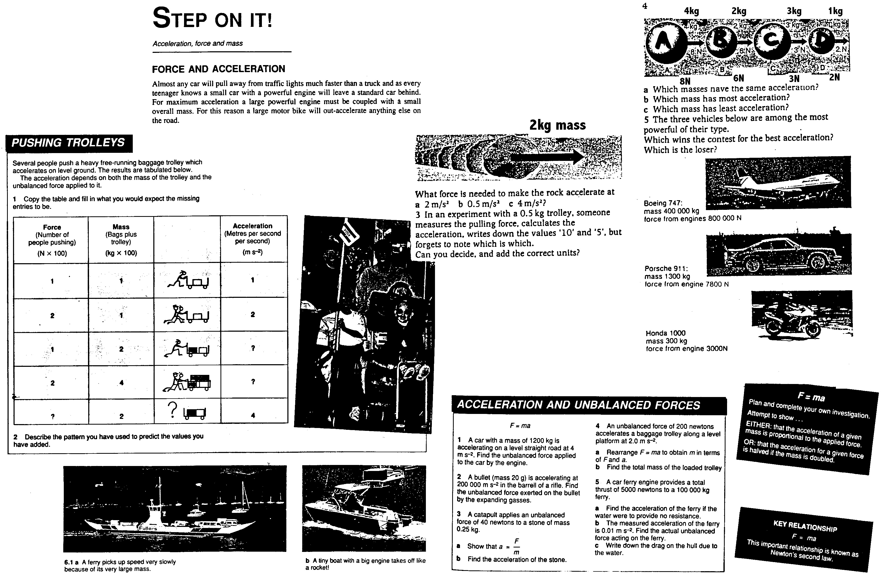

Energy
- Law of Conservation of Energy
Energy is neither created nor destroyed, it just changes form”
- Lightbulb changes from electrical to….
- Hydrodam changes from kinetic to….
- When something happens, energy is transferred
- Energy is needed to carry out work. When we do work, we use up energy
- All calculations involving energy use the unit joule (J) or kilojoule (kJ)

Work
- This is done when a FORCE moves an object over a DISTANCE

Work (J) or (Nm) = Force (N) * Distance (m)
W= F.d

- The amount of work done is a measure of the energy transferred
- Eg A force of 8N is exerted on a body while it moves 3m. How much work is done?
W=F.d
=8*3
=24N
- Something which does work LOSES energy.
- Something which has work done on it GAINS energy
- So… if I push a box across a floor, the amount of energy I lose should equal the amount of energy the box gains. This doesn’t usually happen due to the friction forces between the box and floor
- Frictional forces oppose movement. Often, heat is produced eg braking in cars, bikes.

Activity:
Work OHP

Work examples

- 12J of energy is transferred to a mass while it moves 0.4m. What force was exerted on the mass?

- If a mass of 4kg is accelerated at 3ms⁻² for a distance of 2m, how much work is done?

- A boy loses 60J of energy when he pushes a sled 5m across grass. The energy gained by the sled is 50J

- what has happened to the rest of the energy lost by the boy?
- What must the force of friction be?

POWER

A skier has a mass of 60kg. It takes her 40 s to climb 20m vertically to the top of a slope
Calculate: a) her weight
b) work done when she climbs the slope
c) average power output

Why in reality would she have to do more work than has been calculated?

Power
- Power is the rate at which work is done or energy is changed

Power (W) or (Js⁻¹)= Work done (J) = F*d
Time (s) t

- Eg what is the power output of a woman who exerts a force o 50N to shift a chair 1m in 5 s? P = Work ÷time
= 50*1÷5
= 10W
- Eg A woman cycles along the road and does 1800J of work in one minute. What is her power output? P= Work÷time
= 1800÷60
= 3W

Finish OHP question

Activity:
Body Power p85-7 Yellow Practical Book

Gravitational Potential Energy (E_{p})
- When we do work on something we transfer energy to it
- So.. if we lift an object, we have done work and thus LOST energy which is transferred and STORED in the object after it has been lifted off the ground
- If an object falls, its stored E_{p} is changed to other forms of energy such as sound, kinetic, heat
- An object on the ground has zero gravitational potential energy so the height an object is lifted is important

E_{p} (J) = m.g.Δh
= mass* force due to gravity*change in height (final-initial)

Note: (m*g) (Δh) is the same as F*d
Force due to gravity is 10Nkg⁻¹

- Calculate E_{p} when a 50kg sack of flour is lifted to a table 0.6m in height
E_{p} = 50*10 *(0.6-0)
= 500 * 0.6
= 300Nm ⇒ 300J (The sack of flour has gained 300J)
- Note that if you word this example as “How much work is done when lifting a 50kg sack of flour 0.6m?” , the same answer is achieved

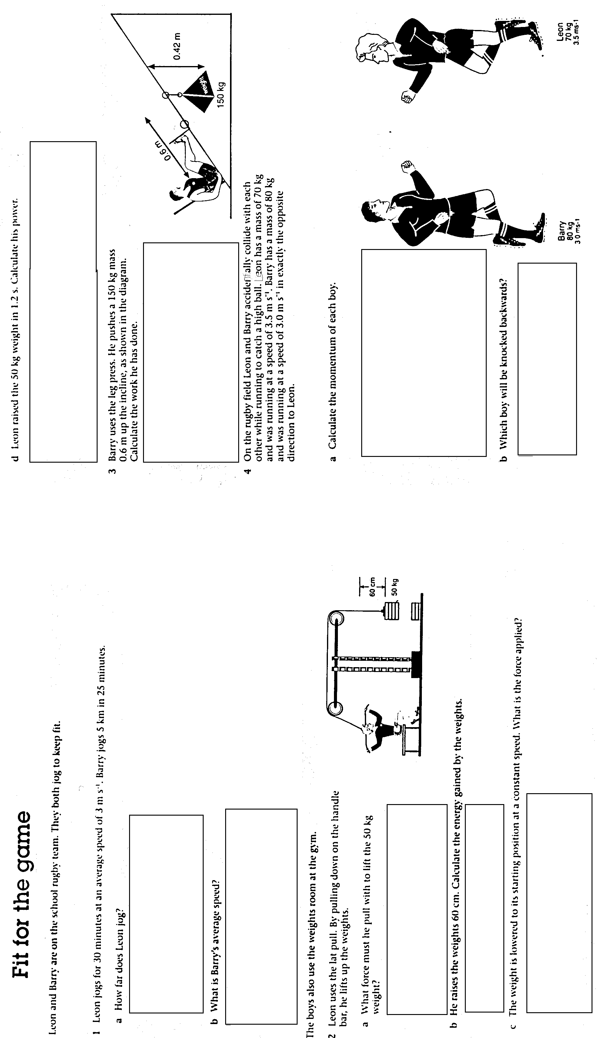
Gravitational Potential Energy

- What is the E_{p} of a 10kg block of chocolate (yumyum!) stored on top of a 3m high cupboard?

- What is the E_{p} of 2kg apples stored in a shopping bag on a shelf 750mm off the ground?

- What is the E_{p} of a 600g bird gliding at 40m?

- What is the change in E_{p} when a 1.5kg packet of sugar falls from a shelf 1.9m above the ground and lands on the bench 1.3m above the ground?

- A builder on a 10m high roof drops a 1kg tile which lands on a deck 150cm above the ground? What is the change in E_{p}?

Kinetic Energy
- This is the energy of moving objects
- Kinetic Energy (E_{k}) is related to mass and speed
- If 2 elephants have the same mass but different speeds, the faster elephant has more E_{k}
- If 2 elephants have the same speed but different masses, the heavier elephant has more E_{k}
E_{k} = ½mv²
= ½*mass*(velocity²)
Unit is JOULES

- Eg What is the kinetic energy of a 1000kg car travelling at 20ms⁻¹?
E_{k} = ½ * 1000* 20²
= 500 * 400
= 200000Nm ⇒

Activity
Pathfinder p46-7 no’s 3,4,7,8,10

